**How to create a MIF file from an RF Studio generated File**

1. Open RF Studio and select the desired device. This device can be opened in either online or offline mode. For the marmoset collar, use the CC1120 device.
2. With the register view open, enter the parameters into the screen. For example, the default 440.2 MHz settings are 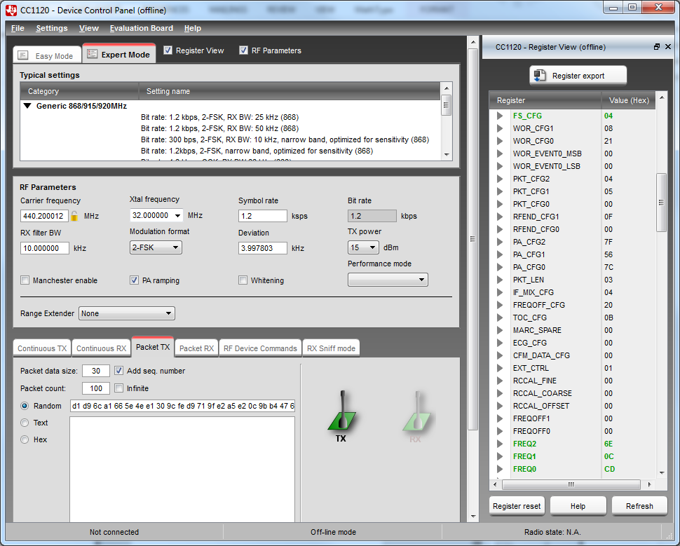
3. Now, click the Register export button in the top right. The following screen should pop up. 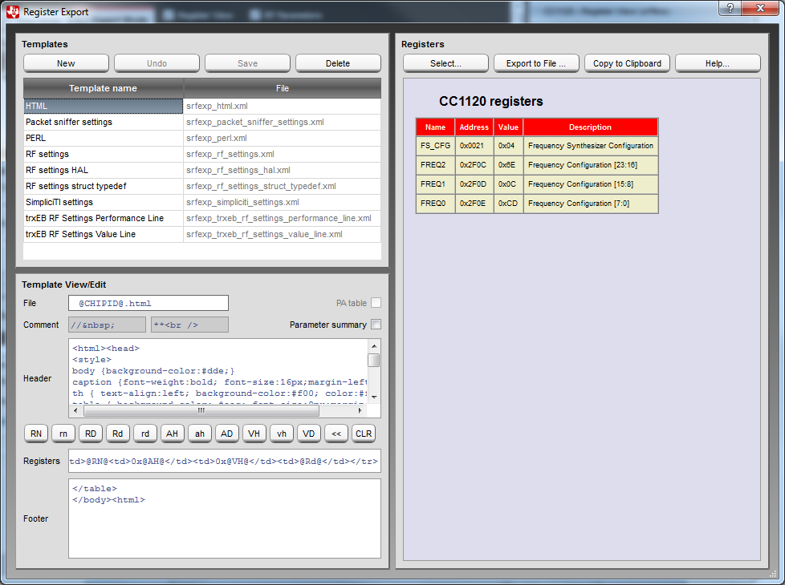
4. Notice only 4 registers are shown. Click select, then the triple arrow to select all registers. Note, you can also simply select the registers you want to change as well.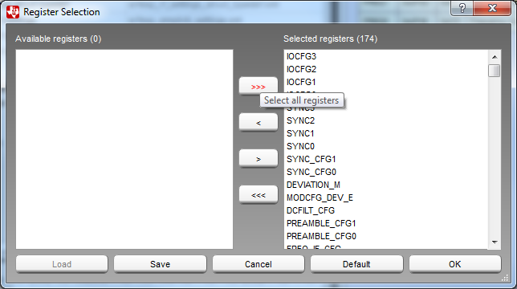
5. Click Ok, then on the make sure the HTML Template name is selected. For some reason, the “HTML” file is exported as an XML, however several XML and HTML parsers have trouble parsing it. Click export to file in the top right, then save it somewhere.
6. Now, open the file you just saved in Microsoft Excel. If this warning pops up, just hit Yes and continue. Note, this part of the tutorial follows an example from http://www.excel-easy.com/examples/xml.html.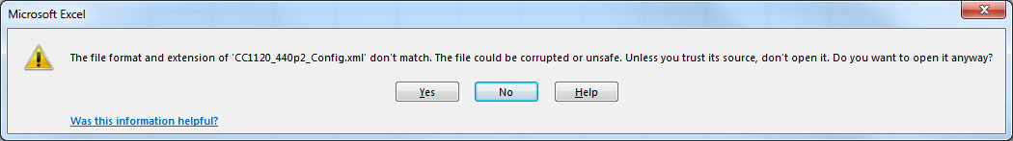
7. Now, the file should be open in excel. First off, delete the first row of the workbook so you have something that looks like this. In order to designate this as an XML file, we need to first provide a schema for the worksheet.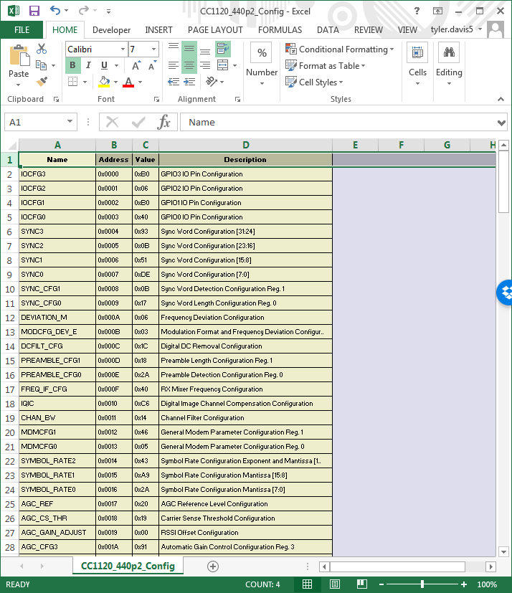
8. Now, make sure you have the Developer tab available. If you don’t, go to File>Options>Customize Ribbon. Add the Developer tab to the list.
9. In the developer tab, click Source, then XML Maps. 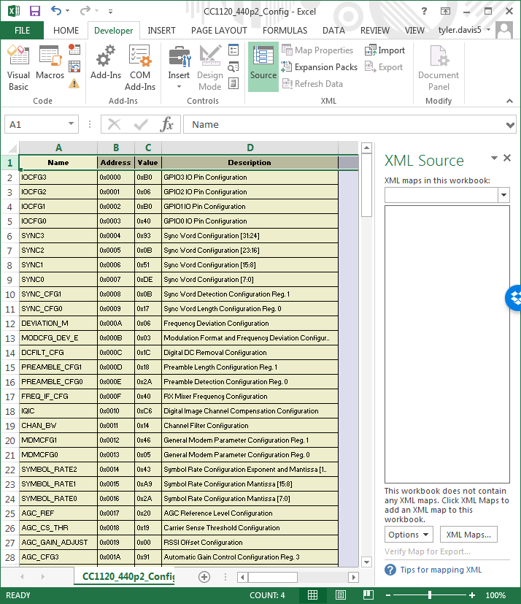
10. IN the XML Maps dialog, click Add, then navigate to the CC1120ExcelSchema.xml file and click open.
11. Next, click and drag the Name, Address, Value, and Description tags from the XML source window to the first row of the appropriate columns. The following shows the mapped Name column. 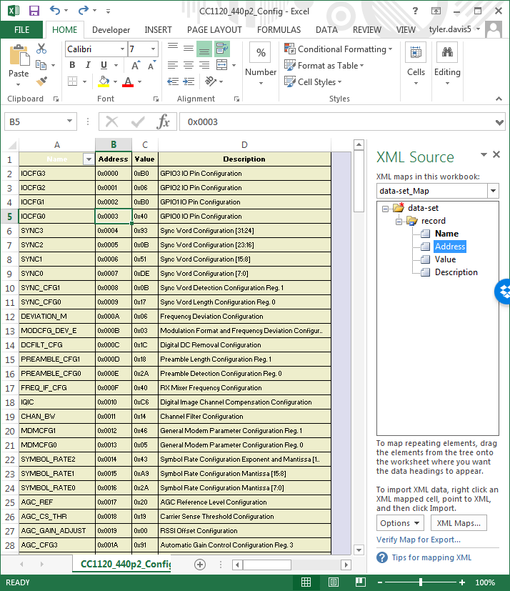
12. Finally, in the developer tab, click export and save the file on your computer.
13. Now, using some python interpreter and a text editor (pythonxy and spyder work well), open FileToMif.py. Change the path, filename, depth, width, addr_radix, data_radix, and outputfile paramters and use the RFXMLtoMIF function to create your MIF file.